**PRACTICAL - 4**

**AIM:** To design Carry look-ahead adder.

THEORY:

The ripple-carry adder, its limiting factor is the time it takes to propagate the carry. The carry look-ahead adder solves this problem by calculating the carry signals in advance, based on the input signals. The result is a reduced carry propagation time.

To be able to understand how the carry look-ahead adder works, we have to manipulate the Boolean expression dealing with the full adder. The Propagate P and generate G in a full-adder, is given as:

Pi= ai⊕ai Carry propagate Gi= ai bi Carry generate

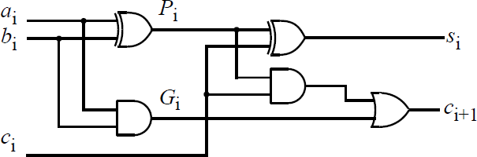

The new expressions for the output sum and the carryout are given by:

Si= Pi⊕Ci-1 Ci+1= Gi+ PiCi

These equations show that a carry signal will be generated in two cases:

1. if both bits ai and bi are 1
2. if either ai or bi is 1 and the carry-in Ci is 1.

Notice that both propagate and generate signals depend only on the input bits and thus will be valid after two and one gate delay respectively.

If one uses the above expression to calculate the carry signals, one does not need to wait for the carry to ripple through all the previous stages to find its proper value. Let’s apply this to a 4-bit adder to make it clear.

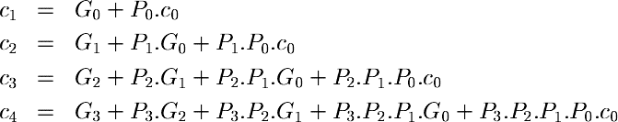Putting i= 0, 1, 2, 3;

These expressions show that C2, C3 and C4 do not depend on its previous carry-in. Therefore C4 does not need to wait for C3 to propagate. As soon as C0 is computed, C4 can reach steady state. The same is also true for C2 and C3.

The disadvantage of CLA is that the carry logic block gets very complicated for more than 4-bits. For that reason, CLAs are usually implemented as 4-bit modules and are used in a hierarchical structure to realize adders that have multiples of 4-bits.

_

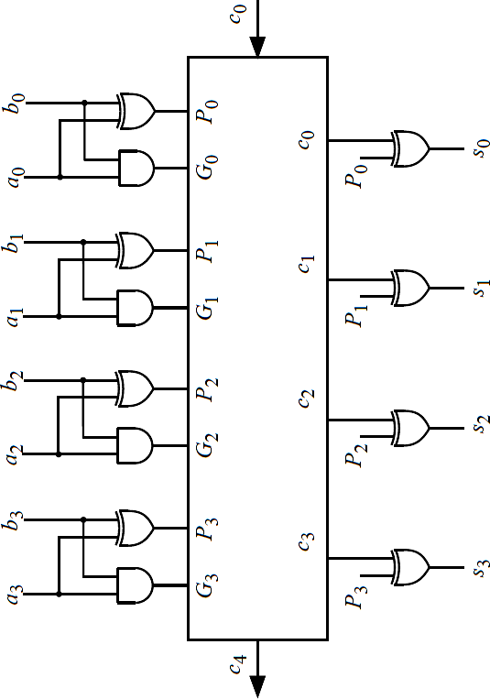-bits.

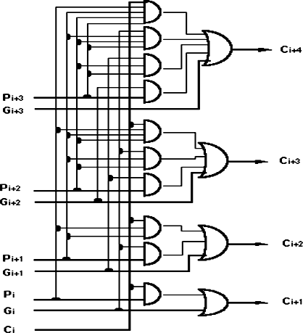

Look ahead carry generator Carry Look Ahead adder

**LABWORK:**

***1. Generate logical circuit for Look ahead carry generator.***

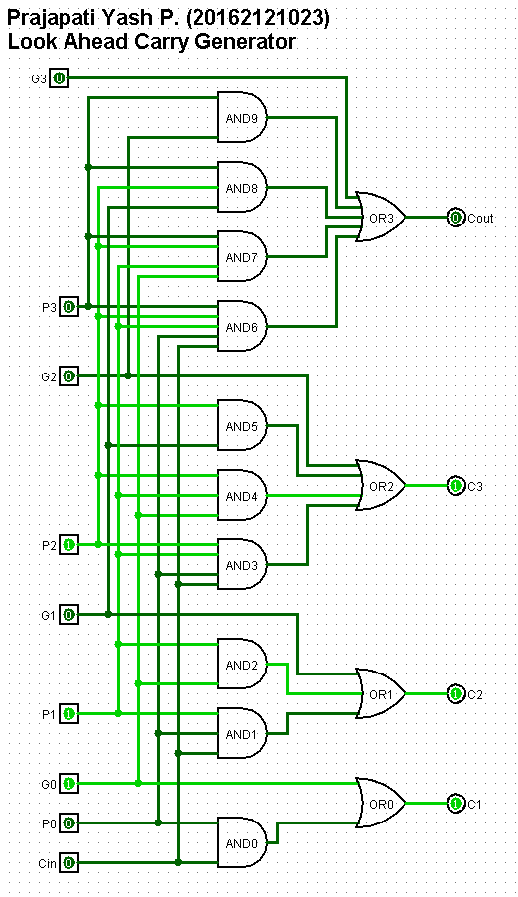

***2. Generate logical circuit for Carry Look Ahead adder.***

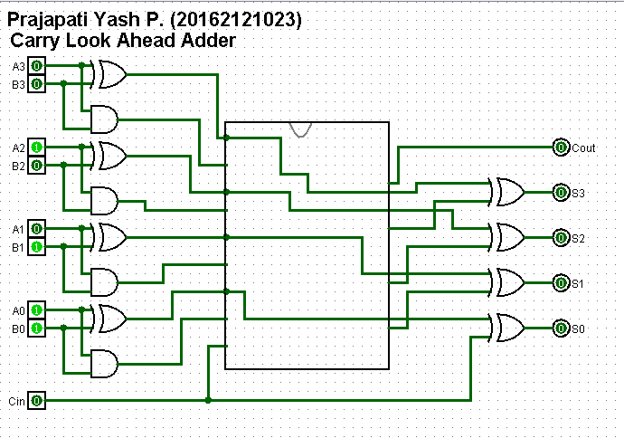

-------------------------------------------------------------------------------------------------------------

***3. Discuss the differences between Carry Look ahead adder and Ripple carry adder based on propagation delay and computation time required in each circuit.***

**ANSWER:**

Ripple carry adder

* A ripple carry adder passes its carry bit through a long logic chain, which is very straightforward to design, but can have a very large delay.
* A ripple carry adder is implemented purely with a half-adder and multiple full adders. The maximum delay is through the carry signal path from the LSB to the MSB which "ripples" through all the adders.

Carry look ahead adder

* A carry-lookahead adder uses a clever algorithm to cut that logic to only a few layers, and thus keeps the delay pretty short even for a worst-case situation.
* A carry look-ahead adder includes additional logic which decodes the inputs directly to determine the carry output of a group of the adders. This special decoding provides an alternate and faster path for the carry information. There are various ways of implementing the carry function.